Content Based Image Retrieval Using Deep Convolutional Neural Networks

Here we are using deep convolution neural networks to find the similar features of the data

We will save the features of the Data in our local database and then we will the distance between the input image feature and the features of the data

If the distance between the features Is low, then they will have most similar features

This technique is used for the unsupervised learning or for the semi-supervised learning. With this technique the data will be labeled by itself

**Code snippets:-**

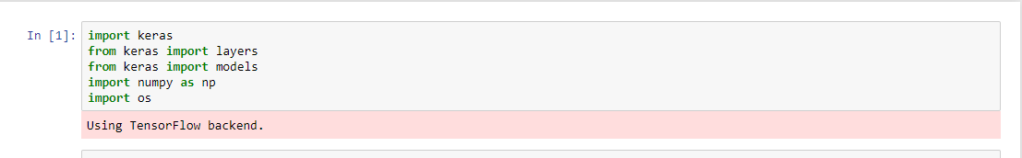

Keras

Importing the Libraries, we are going to use Keras , this is the famous light weighted framework which built on the top of TensorFlow, Theano, Caffe ..

NumPy

Numpy is a numerical python library which deals with High dimension data, like more features, images, etc… This is very fastest python library for the N-D array



Data is a list which is saving the path of the all the images, with the help of the os.listdir() which says the path and if statement checks it is image or not and every path will save in the list

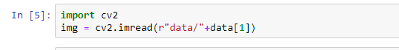

Cv2 is a library which help to read the images and to write or save the images. Here we are checking the image presence in the path of the list

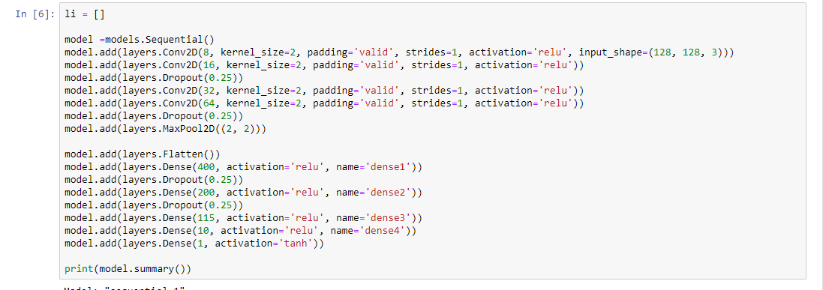

Models is a class with the Sequential Function which keeps the model in a stack process

Here we are having 4 convolutional + Relu layers with input shape 128, 128, 3 (width, height, channels) , with 2 Dropout and 1 MaxPool Layer, Next we are Flattening the layer, and then we are having 5 dense layers , with 2 DropOut

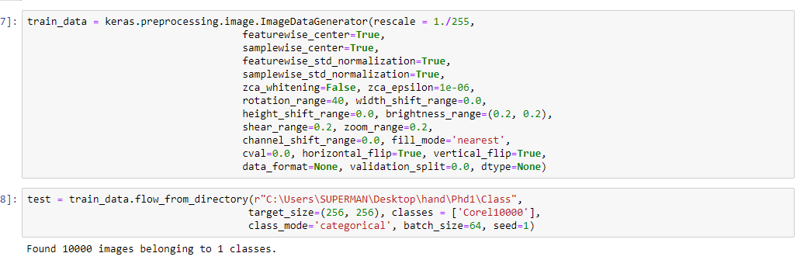

Preprocessing is folder in a keras which help us to do image auguementation like zoom in, zoom out, rotate, shearing, shifting, rescale etc.. to increase the size of the data

Flow from directory help us to take images from folder and intilized with classes, shape, class_mode, etc..

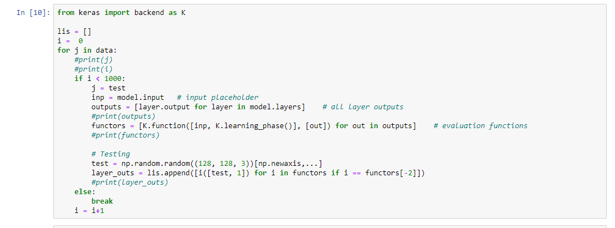

Lis is a Empty list, I Is intilized with the 0, and we are sending the data into the training loop, Here J is the Image, we are only taking 1000 images with 10 classes, model.input taking the input , Output is a list which prints all the outputs of the lists, functors is the learning phase of the model will save the need output features from the layers_outs, in layers_outs we will save the all the data or else we break the loop

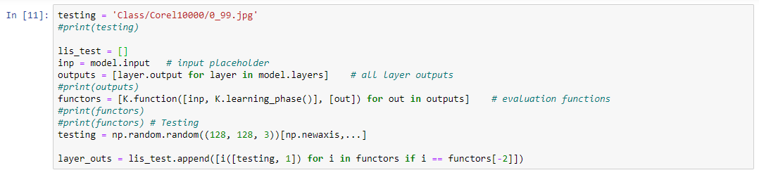

Same process for training will also goes for the testing with only one image

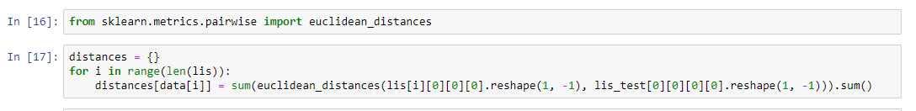

Here we are going to finds all the distances between the features of the database and input image features



We are sorting the distance on the bases of the keys and there items

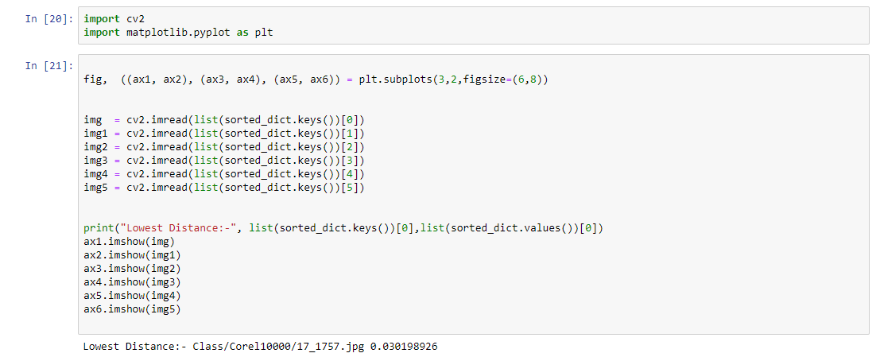

Matplotlib is plotting library which helps to plot the data we are show the images using matplotlib and going to read the images, Creating the 6 Subplots and reading the top six images from dictionary which we are sorted before.

Printing the lowest distance images for the input image

Showing the all the images using matplotlib

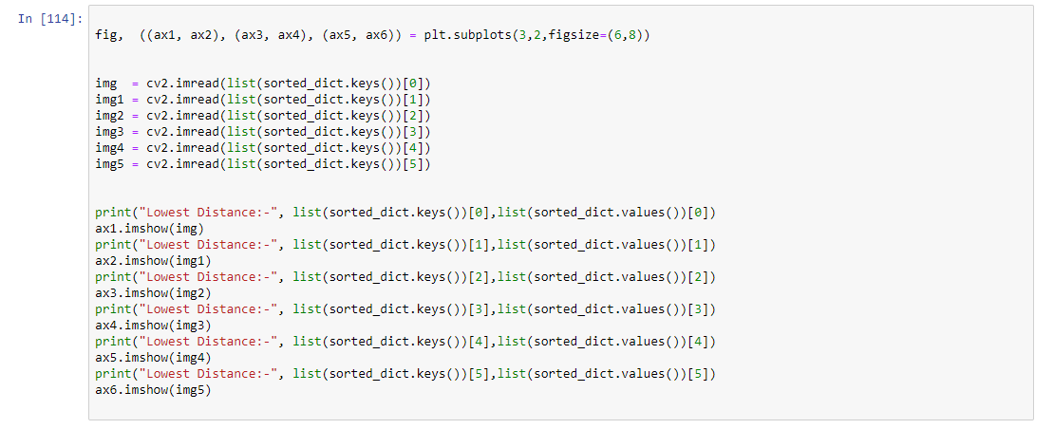

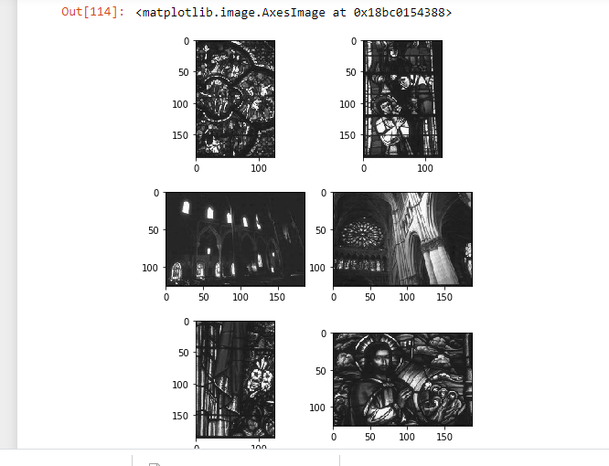 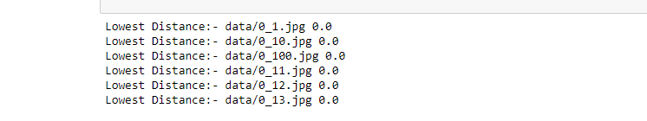

ALL are from the same class with 0 label

Here we are top lowest distances from giving input image

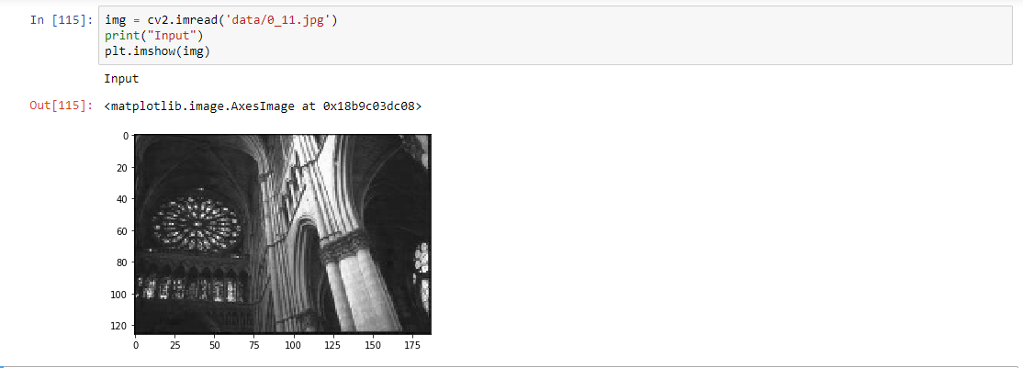

This the imput image given to the model and compare to all the features of the database

Accuracy Score:

Accuracy score says that how much the algorithm is predicting the answer

Formula :

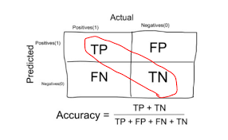

Here we are Using Categorical Cross entropy to find the loss in the data

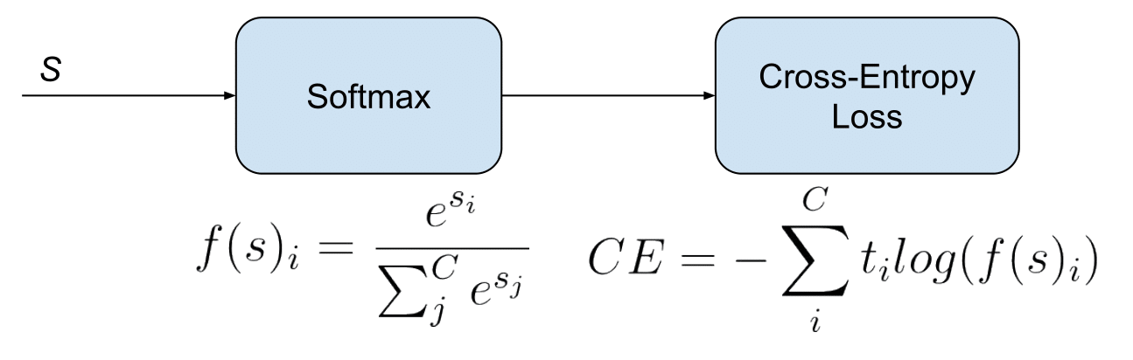

Recall

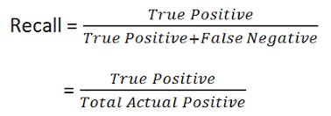

The recall is the ratio tp / (tp + fn) where tp is the number of true positives and fn the number of false negatives. The recall is intuitively the ability of the classifier to find all the positive samples. The best value is 1 and the worst value is 0

Precision

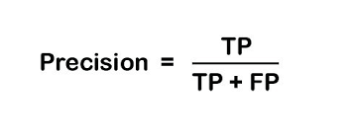

Precision is a metric that quantifies the number of correct positive predictions made. Precision, therefore, calculates the accuracy for the minority class. It is calculated as the ratio of correctly predicted positive examples divided by the total number of positive examples that were predicted.

F1 Score

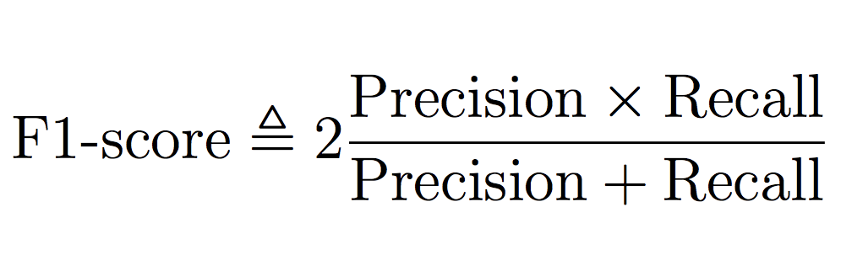

The F score, also called the F1 score or F measure, is a measure of a test's accuracy. The F score is defined as the weighted harmonic mean of the test's precision and recall. This score is calculated according to: ... The F score reaches the best value, meaning perfect precision and recall, at a value of 1

CSV FILE for the total data

All the data was saved in this file like precision, recall, f1score, accuracy, loss for both the training and the validation data

Link for The GitHub:

<https://github.com/saichandrareddy1>